**CHAPTER - 1**

# INTRODUCION

**1.1 PROJECT DESCRIPTION**

Medtopia basically is a project which mainly focuses on getting or developing the relationship between the doctors and the patient. Medtopia has created a web base platform where both hospitals and patients can get registered. The main head of this project is SUPER ADMIN.

SUPER ADMIN: -

Super admin is the department which has access and full control over the project. He allows the hospital organization to get registered first. Before getting the hospital registered, super admin department starts with the background verification of the hospital and once when the hospital meets the necessary requirements, the hospital organization gets finally registered and a list out the services and treatments which they offer. Coming to the User/Patient part Super Admin has given the opportunity.

PATIENTS: -

According to MEDTOPIA, patients or they can also be called as users can get registered easily. Getting registered into MEDTOPIA can easily done by users if they have the basic requirements i.e., an electronic gadget and an email address. They can also get registered to MEDTOPIA through the phone numbers.

Once the patients get successfully registered, he/she will get to search the relevant hospitals and doctors for the treatment he/she requires.

People find it difficult to choose a hospital where they will get care. The discovery that patients don’t like going to some random hospital to get the treatment continues this search.

People/patients search for a high-quality treatment facility where they can be cared for their health condition and achieve the positive outcome. When choosing which hospital to get cared for it, it in really required that they go through many hospital reports and reviews. Based on the analysis choosing the hospital help, patients to compare which hospital is better and which is really not.

To make this analysis, MEDTOPIA has understood the patient requirements and have allowed users to give reviews and ratings for both the hospital and the doctors which makes patients choose to get better treatment easily.

It is self-evident that not every hospital deals with all forms of care and this is one aspect or advantage that allows patients to narrow down the selection of hospital to select from based on the health needs.

When searching for the best hospital, the most important thing to remember is to look for the doctor’s qualification and their specialization and can also search for the doctors based on their experience and obviously, while searching for the hospitals, it is very important that hospitals technology. We cannot and will not choose the hospital which is unhygienic and which lacks in both the medical technology and the medical equipment’s and instruments along with this hospital’s cleanliness also plays a major role for the patients while selecting the hospitals for their treatment.

The main advantage of getting the treatment via MEDTOPIA is that, patient doesn’t have to pay a single rupee to the hospital until the treatment gets completed, the MEDTOPIA takes care of hospital charges until the treatment is being done, in this way patient can’t need to worry about the emergency financial crisis. The hospital fees can later be paid to the MEDTOPIA.

But MEDTOPIA charges 10% of the hospital for providing the service for both the hospitals and the patients.

**CHAPTER – 2**

# LITERATURE SURVEY

**2.1 EXISTING AND PROPOSED SYSTEM**

This section includes tips for optimizing the efficiency of the intended system and briefly explains the present system, its flaws and restrictions.

**EXISTING SYSTEM:**

The system now in use is referred to as the existing system. Currently, all medical operations are carried out manually. In other words, if a patient wishes to see a doctor, he can go there till his appointment is called. This makes the person exceedingly challenging. Tickets for both in-patients and out-patients are given out immediately. The primary drawback is that it takes time.

## LIMITATIONS OF EXISTING SYSTEM

* Data security is poor.

* It takes a long time.

* Uses a significant amount of paper.

* Manual tasks

* There is no direct involvement of higher officials.

The system has to be digitized in order to get rid of all these restrictions and improve performance.

**PROPOSED SYSTEM:**

Software for the hospital administration system is user-friendly. The system's primary goals are to display and assist you in gathering the majority of data concerning hospitality and medical services. The system is relatively easy to install and develop. The system works in practically all settings and calls for very little operating system. The following is a list of the primary goals of the suggested system:

* The physicians are quickly assigned patients.

* Search for Doctors is an option.

* The patient lists of today make it easier for doctors to look up patients.

## ADVATAGES OF PROPOSED SYSTEM

The system is relatively easy to install and develop. The system works in practically all settings and calls for very little system resources.

* The safety of the data.

* Assure the data's correctness.

* The system is under the supervision of the administrator.

* Lessen the harm that machines sustain.

* Keep manual data input to a minimum.

* Increased effectiveness.

* Interactive and user-friendly.

* Minimum time necessary.

**2.2 FEASIBILITY STUDY**

At this stage, project performance is analysed and a business proposal is proposed, which contains the most common project plan and other cost estimates. During the process analysis, a feasibility study was conducted to determine whether the proposed system was implemented to ensure that the proposed system would not be a burden to the company.

It is important to understand the basic requirements of a learning program if possible.

**Three key points from a possible study:**

* **ECONOMICAL FEASIBILITY**

* **TECHNICAL FEASIBILITY**

##  SOCIAL FEASIBILITY

* **ECONOMICAL FEASIBILITY:**

The objective of this study is to evaluate the program's financial impact on the company. The corporation only makes a little amount of investment in research and programmer development. Costs should be estimated. Therefore, the system was also established on a budget basis, as most of the technologies used were provided free of charge.

* **TECHNICAL FEASIBILITY:**

This research was carried out to evaluate the system's technical needs and effectiveness on a technical level. Any software created shouldn't have a significant demand for currently available technological resources, which would increase that demand. This leads to higher demand for the consumer. The upgraded system should have moderate requirements, as its use requires little or no change.

* **SOCIAL FEASIBILITY:**

A capability for learning to evaluate system user approval. This includes the instruction users receive on how to utilise the technology efficiently. Users should see this as a welcome level and not feel intimidated by the system. User acceptance only depends on training and familiarizing users with the system. Ways. You need to boost your self-confidence in order to be able to give constructive criticism. This is acceptable because you are the last user of the program.

**2.3 TOOLS AND TECHNOLOGY**

**React JS:**

React is a front-end JavaScript toolkit that is free and open-source for creating software platforms based on UI components. It is kept up-to-date by Meta and a group of independent programmers and businesses. With a platform like Next.js, React may be the foundation for single-page, mobile, or client apps. Making React apps typically necessitates the use of extra libraries for routing and specific client-side features because React is only worried with state management and presenting that information to the DOM.

Jordan Walke is React's originator. The Meta and community are React's programmers. React was first released on May 29, 2013, which was nine years ago, and React 18.2.0 will be stable on June 14, 2022. The React source may be found at github.com/facebook/react. JavaScript is used to create this React. React grows by utilising the Digital platform. In React, the MIT License is utilised for licencing purposes and the JavaScript library type will be used for libraries.

**React JS Features:**

Currently, programmers consider ReactJS to be the greatest JavaScript framework. It is playing a crucial part in the ecology of the front-end. The below are some of ReactJS's key characteristics.

* JSX

* Mechanisms

* One-way Data Binding

* Virtual DOM

* Plainness

* Enactment

**Pros and Cons of React JS:**

The most popular open-source JavaScript library nowadays is ReactJS. It facilitates the development of remarkable web applications with little effort and programming. ReactJS's primary goal is to create User Interfaces (UI) that increase the speed of apps. The below are some significant advantages and disadvantages of ReactJS:

**Advantage of ReactJS:**

* Simple to Learn and Use
* Easier to Create Dynamic Web Applications
* Re - usable Component
* Effective Improvement
* built - in support for Helpful Tools
* SEO Compliant
* The Advantages of Using a JavaScript Library

**Disadvantage of ReactJS:**

* Poor documentation
* a rapid rate of development  see part JSX as a roadblock

**Node JS:**

A server-side platform called Node.js is built on Google Chrome's Javascript Library. One of most recent edition is v0.10.36, and Ryan Dahl developed it in 2009. This is a cross-platform runtime program for creating open source connectivity and application code. JavaScript is used to create Node.js programmes, which are then executed on Unix, OS X, and Windows Xp using the Node.js engine. The extensive collection of JavaScript components included with Node.js also helps it that much simpler to create Node.js web apps.

Instead of establishing a new task for every query, the Node js application operates in a single application. Because the class library provides a set of concurrent I/O data structures that prevent JavaScript code from stopping and also because libraries in Node.js are commonly created using non-blocking principles, delaying activity is exemption instead of the norm in Node.js. Node.js's usage is currently soaring. Node.js is currently used via well firms like Youtube, Uber, Ebay, Facebook, and more. Node.js is the sixth most widely used technology amongst coders, with over one-third of developers ranking it for their first choice, which according Stack Overflow's 2021 Programmer Survey.

Node.js is appropriate for both backend and frontend development for a number of reasons, including:

**▪** Reusability

**▪** Productivity and Developer Efficiency

**▪** Huge Community

**Node.js Frameworks:**

Various frameworks have been developed to aid in the completion of tasks that are still challenging for Node.js to handle.

Some of the most popular Node.js frameworks are the ones listed below:

* Nest.js – This is a potent backend technology for Node.js that may be used to build corporate apps.

* Express.js - if it has a big number of HTTP helpers and is a compact, basically built framework.

* Socket.io – - if it is a framework that is simple, small, and contains a large number of HTTP tools.

* Meteor.js – Real-time flexibility, configurable imports, front-to-back communication, and API security are made possible as a result.

* Koa.js – This employs asynchronous techniques to streamline error checking and boost software quality.

* Loopback.io – - It offers a variety of features that support the flow, allowing designers to create APIs rapidly.

The primary benefit of utilising Node.js is the speed it offers. Mapreduce, clientserver communication, improvement, and advancement are all completed quickly. Node.js offers occurrence two links between the client and the server as a consequence, enabling network data transfer between the two parties. Node.js thrives in the kinds of scalability and actual life that we're progressively demanding of our web servers because of its distinctive I/O strategy.

In addition to being quick and lightweight, Node.js also makes it possible to use JavaScript code on both the front end and the back end, which opens up new development opportunities. Due to flexibility of the frontend, our tech community will be substantially more effective and cross-functional, decreasing production expresses.

**Express.js:**

Express is a Node.js web framework that is quick, forceful, necessary, and modest. You might imagine express as a layer added to Node.js that assists in managing a server and routes. It offers a complete collection of tools for creating online and mobile apps.

Here are a few of the key components of the Express framework:

* Designing single-page, multi-page, and flexible web apps may be done with it.

* It enables software to be configured to reply to HTTP requests.

* It specifies a routing table that is utilised to carry out various operations according to the HTTP method and URL.

* It enables the dynamic rendering of HTML pages by using template parameters.

**PostgreSQL Database connectivity:**

Open-Source Object-Relational Database Management System (ORDBMS) is what PostgreSQL is. Information is securely stored via this method, and it supports best practises by enabling data recovery once a request has been fulfilled.

* On July 8, 1996, PostgreSQL made its debut at the University of California.

* But before Oracle, it was the first DBMS to implement MVCC [Multi-Version Synchronization]. Oracle refers to the snapshots isolation characteristic as the cross synchronisation feature.

* It is programmed in the C language.

* Because it is cross-platform, PostgreSQL may be used with a variety of operating systems, including Microsoft Windows, UNIX, FreeBSD, Mac OS X, Solaris, HPUX, and Linux.

* The current databases again for macOS server is PostgreSQL.

* PostgreSQL, which is sometimes pronounced Post-gress-Q-L, was created by the PostgreSQL Global Development Board; no commercial company or group, has any authority over it.

* PostgreSQL will provide us with the option to implement functionality using a wide range of methods, including Java, C, and C++.

* This allows us to explain our functional languages, index kinds, and data types. We can even build a unique plugin to better meet our needs.

* Since its original code is available under the PostgreSQL licence, we are allowed to use, modify, and distribute PostgreSQL in any way.

* The transaction and the ACID (Atomicity, Consistency, Isolation, and Durability) characteristics are followed by PostgreSQL.

* PostgreSQL's main goal is to manage a range of tasks, from simple technologies to online services or the centralized data with the many concurrent users.

**PostgreSQL Features:**

The essential features of PostgreSQL are as follows:

* Free to download

* Compatible on several operation systems

* Compatible with various programming languages

* Compatible with Data Integrity

* Support multiple features of SQL

* Highly Reliable

* Secure

* Highly extensible

* Compatible with multiple data types

**2.4 HARDWARE AND SOFTWARE REQUIREMENTS**

The hardware and software requirements section describe the hardware and software components required for the development project.

**HARDWARE REQUIREMENTS:**

* RAM: 8GB

* Hard Disk: 500GB

* Processor: Intel Core i7

**SOFTWARE REQUIREMENTS:**

* Operating System: Windows 10

* Frontend: React JS

* Backend: Node JS

* Framework: Express.JS

* IDE: Visual Studio Code

* Database: PostgreSQL

**CHAPTER – 3**

# SOFTWARE REQUIREMENTS SPECIFICATIONS

This project aims to analyze the design of several applications and make the applications more user-friendly. For this reason, it is very important to simplify the transition from one screen to another while reducing user typing.

**3.1 Functional Requirements**

**Software Requirements**

To develop applications, the following software requirements apply

* React JS
* Node JS
* Express.JS
* PostgreSQL

**Operating Systems supported**

✓ Windows 10

**Technologies and Languages used to Develop**

* React JS
* Node JS
* Express.js (Framework)

**Hardware Requirements**

For developing the application, the following are the Hardware Requirements:

* RAM: 8GB

* Hard Disk: 500GB

* Processor: Intel Core i7

**3.2 MODULES**

1. **Login and Registration:**

Both users and admin can get registered, further they can login with valid credentials.

1. **Users:**

Users who are also called patients should register first, later they are allowed to login and choose the hospital and the treatment they need of their own choice. Users can also give the review on the hospital based on their personal experience they experienced during the treatment. Users can contact admin regarding any queries, they can even chat with the admin.

1. **Admin:**

Admin who is also called as hospital management, first of all they need to get registered only when the Super Admin approves. Later Admin can add services they provide, about the hospital and the treatment and surgeries. Admin handles Doctors and Hospital Staff by allotting them to required or necessary treatment that needs to be done as per user’s needs. Admin also has or can make contact with users.

1. **Super Admin:**

Super Admin adds the hospital management or who are also called as admin, Users only if they provide valid details during the registration.

Super Admin saves information using cookies which they gets from the search history of admins and users.

During the registration of the Admins, Super Admin traces the location of the hospital and make it easier for patients to search for the hospitals which is near to them.

Super Admin saves all the users data and provides it to the admin so that admin can get to know about the patients.

Super Admin creates categories and sub categories of the treatments which the hospital provides.

**CHAPTER – 4**

# SYSTEM DESIGN

**4.1 ARCHITECTURE:**

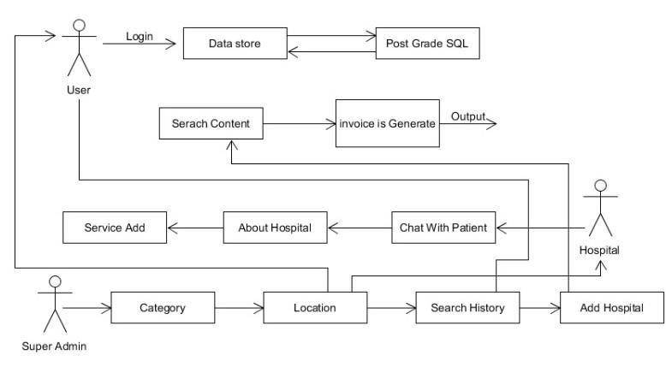

## Figure 4.1: Architecture Diagram

**4.2 COMPONENT DIAGRAM:**

1. **User:**

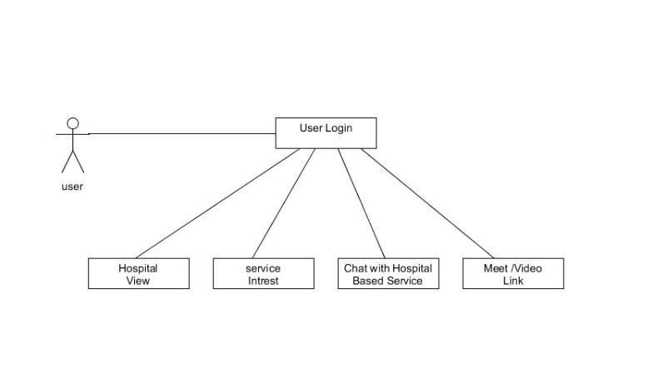

**Figure 4.2.1: - User Component Diagram**

1. **Super Admin:**

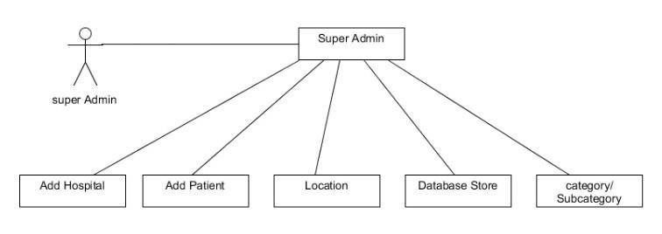

**Figure 4.2.2: - Super Admin Component Diagram**

1. **Hospital:**

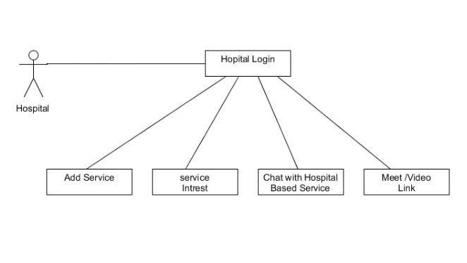

**Figure 4.2.3: - Hospital Component Diagram**

**CHAPTER – 5**

# DETAILED DESING

**5.1 Use Case Diagram:**

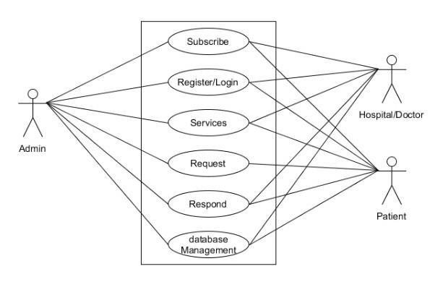

## Figure 5.1: - Use Case Diagram of Medtopia

**5.2 Sequence Diagrams:**

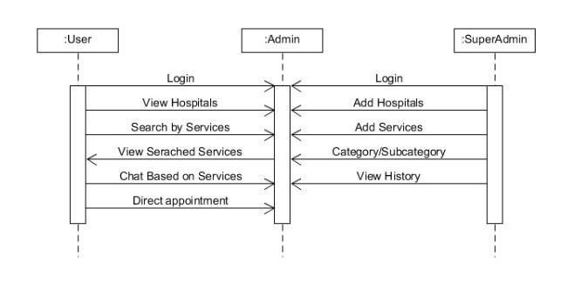

## Figure 5.2: - Sequence Diagram of Medtopia

**5.3 Class Diagram:**

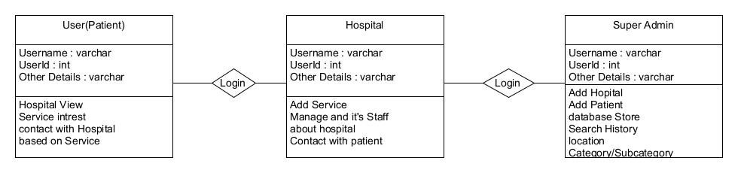

**Figure 5.3: - Class Diagram**

**5.4 Activity Diagram:**

**A. User Activity Diagram:**

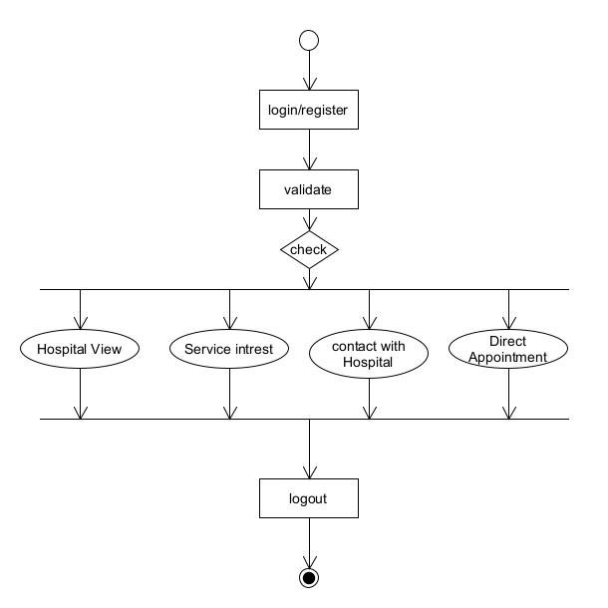

## Figure 5.4.A: - User Activity Diagram

**B. Super Admin Activity Diagram:**

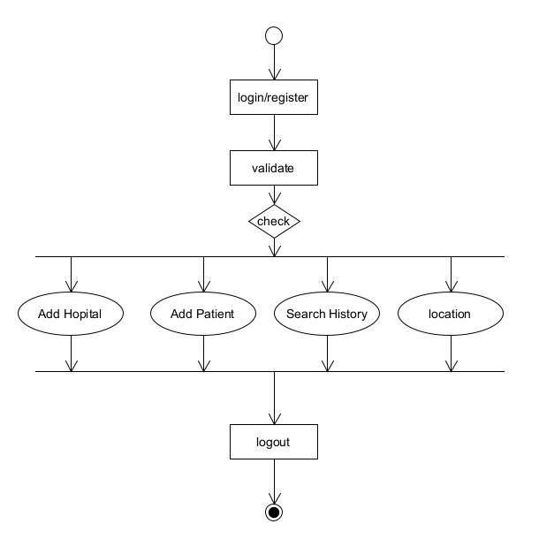

## Figure 5.4.B: - Super Admin Activity Diagram

**C. Hospital Activity Diagram:**

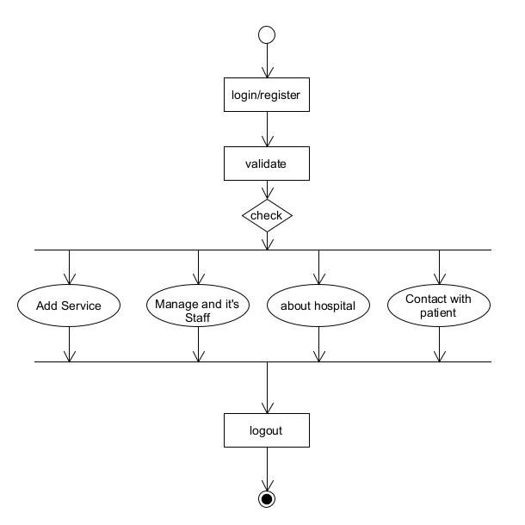

## Figure 5.4.C: - Hospital Activity Diagram

**5.5 Database Design:**

**a) User:**

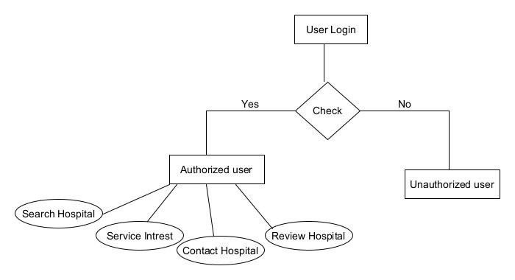

## Figure 5.5.a: - User Database Design

**b) Hospital:**

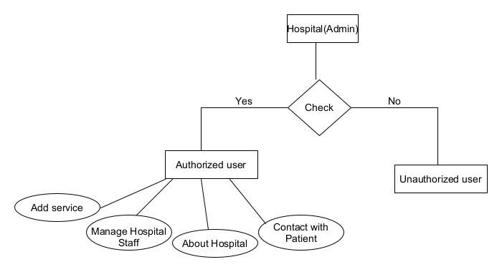

## Figure 5.5.b: - Hospital Database Design

**c) Super Admin:**

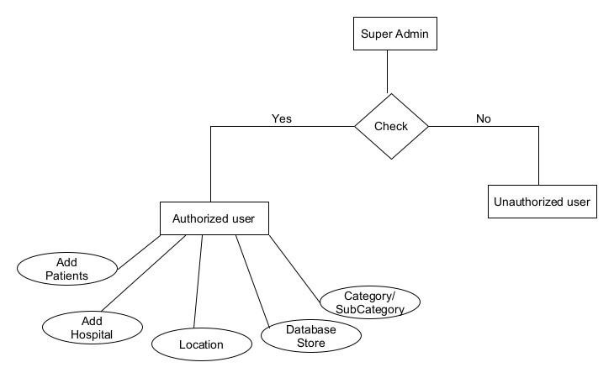

## Figure 5.5.c: - Super Admin Database Design

**5.6 Data Flow Diagram:**

**a) User:**

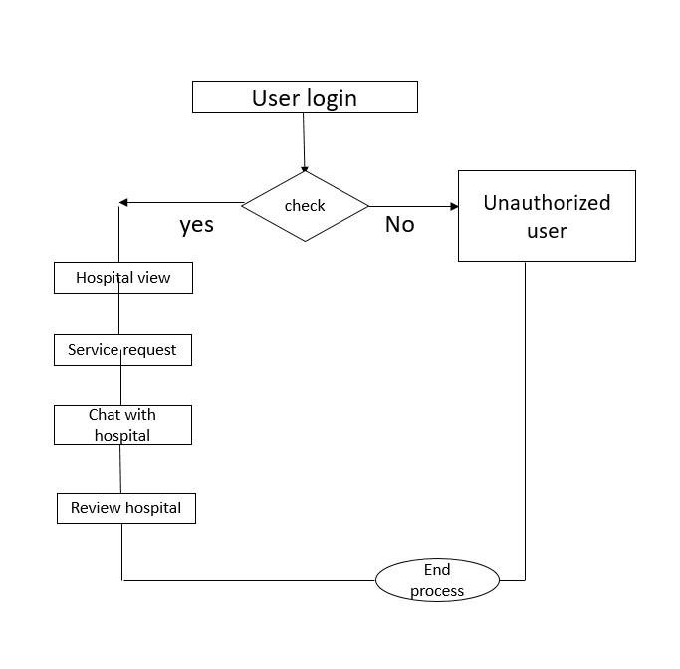

## Figure 5.6.a: - User Dataflow Diagram

1. **Hospital:**

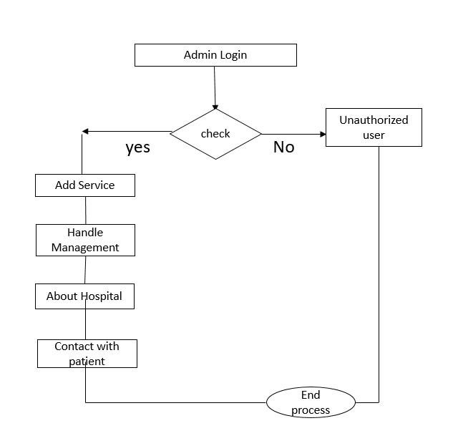

**Figure 5.6.b: - Hospital Dataflow Diagram**

1. **Super Admin:**

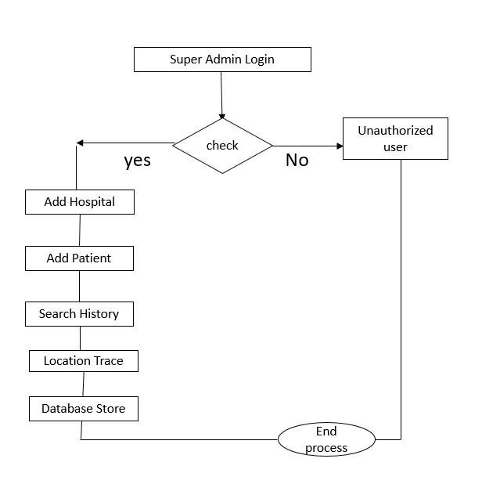

**Figure 5.6.b: - Super Admin Dataflow Diagram**

**CHAPTER – 6**

# IMPLEMENTATION

**6.1 METHODOLOGY**

**Binary Search: -**

Finding a certain component in the collection is the method of locating. The method is deemed effective and provides the entity's location if the component is present in the list. If not, the search is deemed fruitless. The two most used search methods are linear search and binary search.

The search method that performs well on part of a sample is binary search. Therefore, we must make sure that the list is sorted before utilising the binary search strategy to find an element in it. The divide - and - conquer strategy is used in binary search, where the item is evaluated to the median value of the list after the list is divided into two halves. The position of the center pixel is provided if a match is discovered. Alternatively, pending the results of the match, we explore into any of the other halves.

**Bubble sort Algorithm: -**

The way bubble sort operates is the easiest. Since bubble sort may be asked as a problem in an exam, students may find this article to be both highly informative and engaging. So, it's crucial to have a conversation about it.

When doing a bubble sort, neighboring components are continuously swapped until the desired order is broken. The reason it is termed bubble sort because the way array items move is quite similar to how air bubbles flow in water. In the same way as bubbles in height of water to the top, each loop of the bubble sort causes the array items to migrate toward the end. Although it is easy to use, bubble sort performs poorly in the real world, hence it is mostly used as a teaching tool. Large amounts of data are not appropriate for it. Bubble sort has an O (n2) average but also the worst difficulty, where n represents the number of elements.

Bubble short is majorly used where -

i. Complexity does not matter

ii. Simple and short code is preferred

**JSON Web Token: -**

Several assertions are encoded in a JSON object using a JSON Web Token. Some of these assertions have clear meanings, while others are left up to the users' interpretation. Typical allegations are:

* Issuer (iss)
* Subject (sub)
* Audience (aud)
* Expiration time (exp)
* Not before (nbf)
* Issued at (iat)
* JWT ID (jti)

Many people have heard some of these assertions. Usually, the subject claim (sub) specifies who or for what purpose the JWT is issued. JWTs can be made invalid after a set length of time by using the issued at claim (iat) to store the date at they were made. Additional unique claims can be included.

Typically, a JWT is combined with a signatures or secrecy. These are managed by JSON Web Signature (JWS) and JSON Web Encryption, which are separate specifications (JWE). A JWT may be verified against alterations using a signature. On either hand, encryption ensures that only certain persons may access the JWT's content.

## Blowfish Algorithm with Examples: -

Bruce Schneider created the encryption method known as Blowfish in 1993 as a replacement for the DES Encryption Technique. Since no efficient decryption method has been discovered to yet, it is substantially quicker than DES and offers a decent encryption rate. One of the first safe block cyphers, it may be used by anybody as it is not protected by any patents.

1. block Size: 64-bits
2. key Size: 32-bits to 448-bits variable size
3. number of sub keys: 18 [P-array]
4. number of rounds: 16
5. number of substitution boxes: 4 [each having 512 entries of 32-bits each]

**6.2 Screen Shots:**

**A] User Page Details:**

**a] User Register Page:**

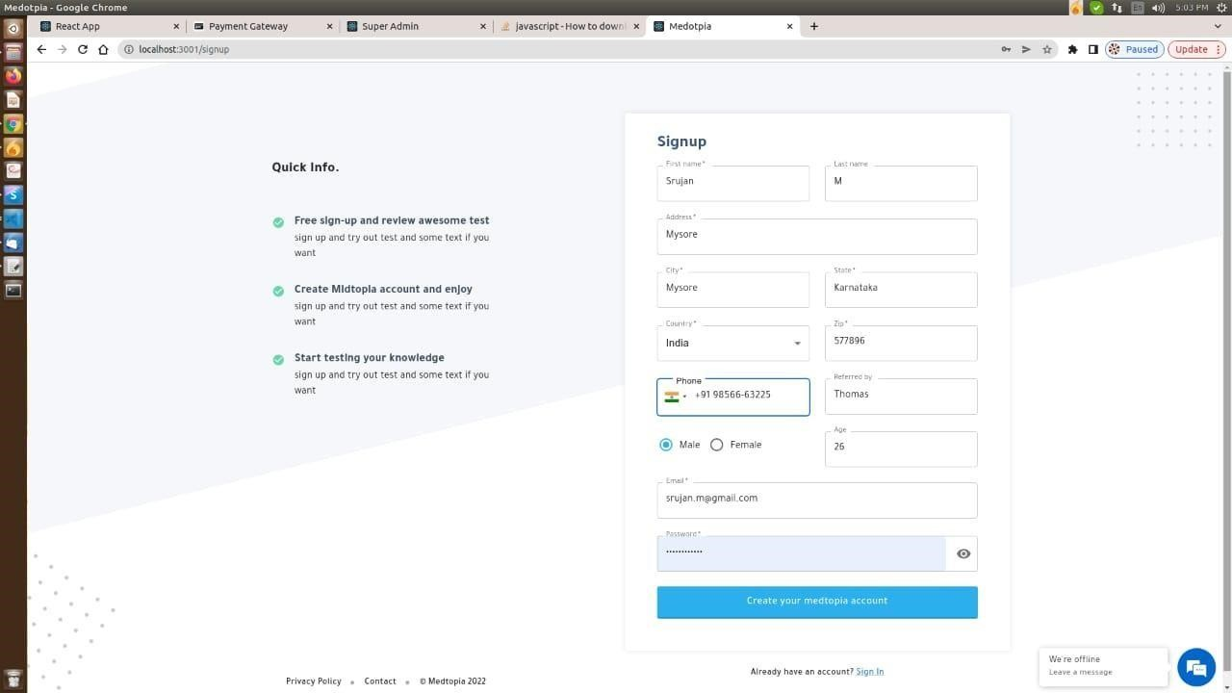

### Figure 6.2.a: - User Register Page

**b] User Login Page:**

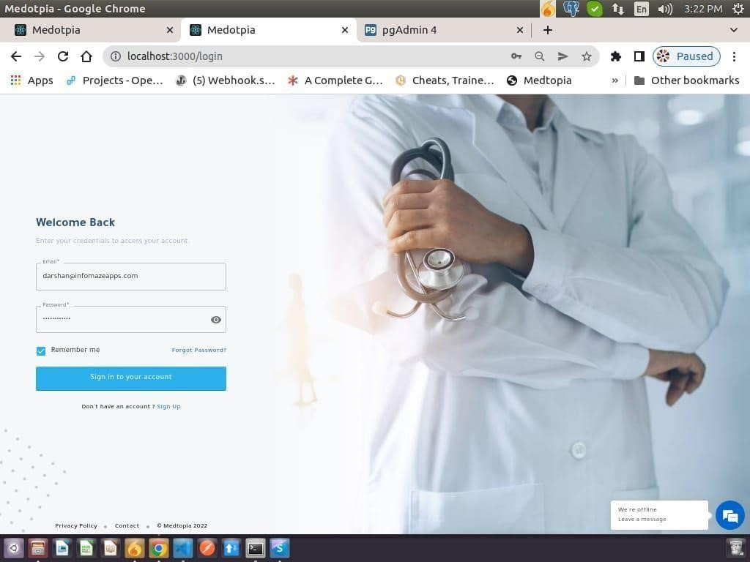

### Figure 6.2.b: - User Login Page

**c] User Dashboard Page:**

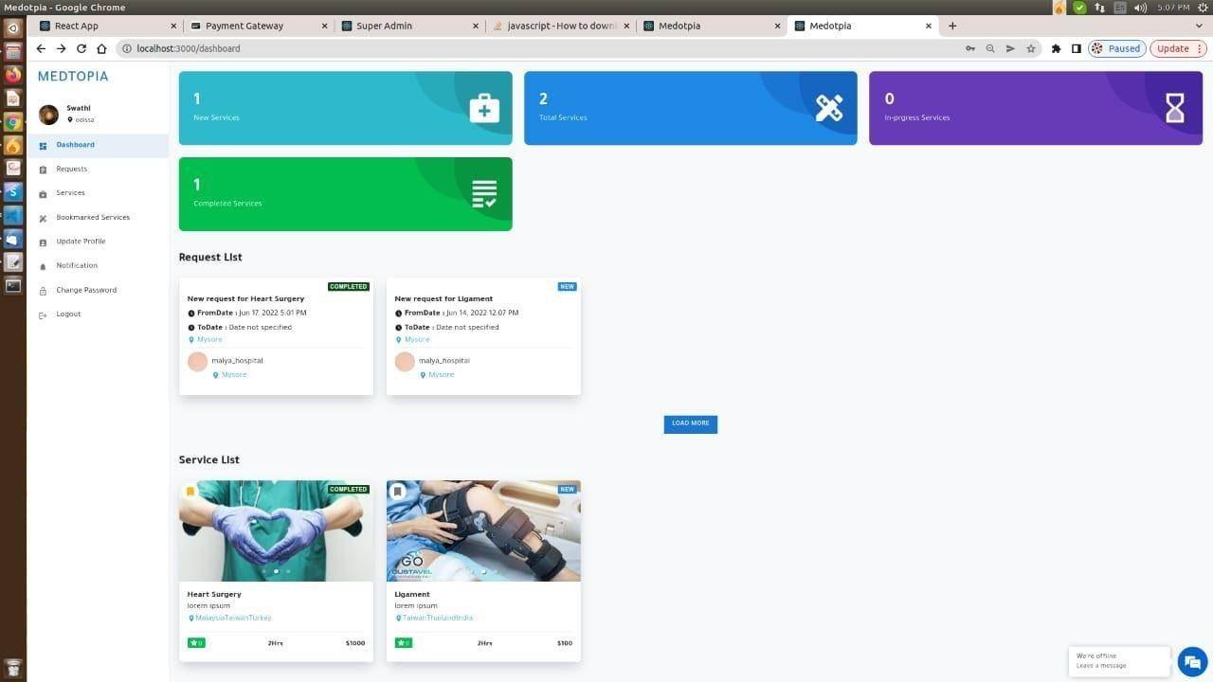

### Figure 6.2.c: - User Dashboard Page

**d] Different Services for User from Hospital:**

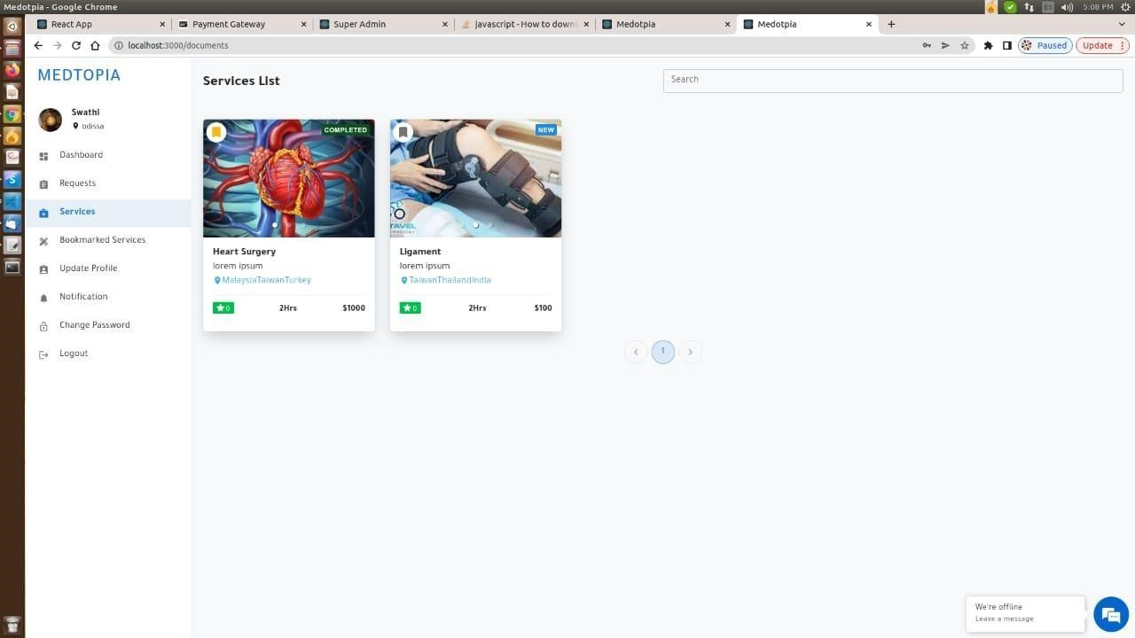

### Figure 6.2.d: - Different Services for User from Hospital

**e] User Notification List Page:**

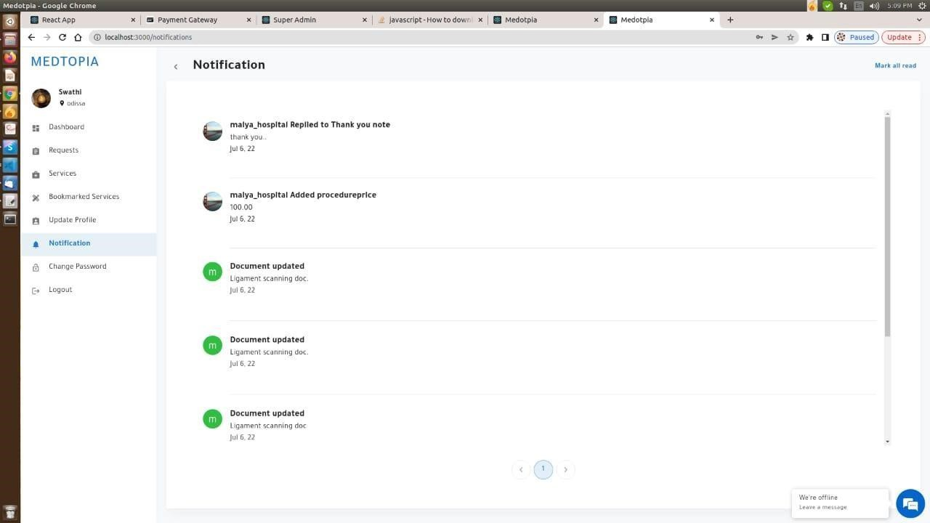

### Figure 6.2.e: User Notification List Page

**f] User & Hospital Chat Page:**

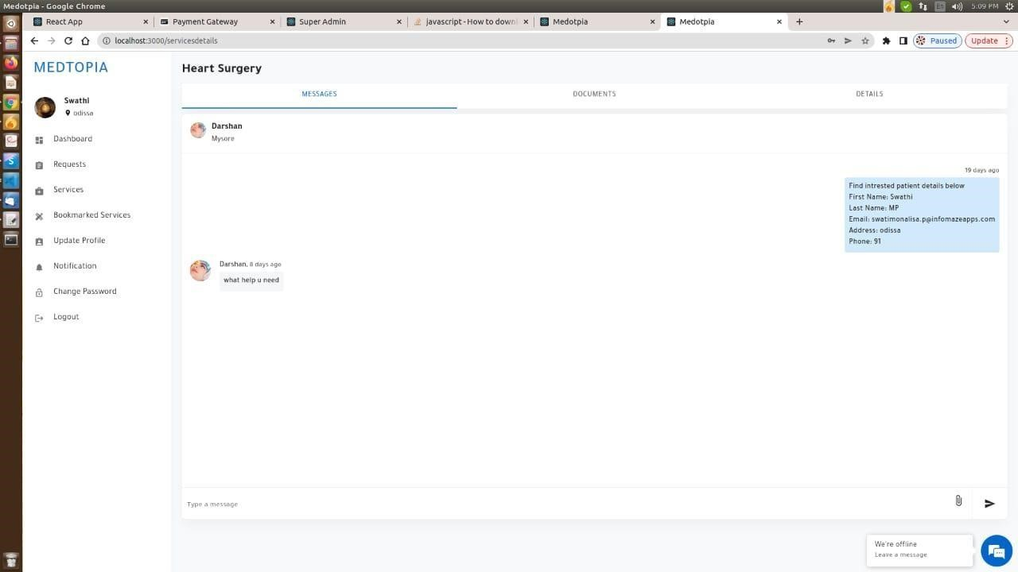

### Figure 6.2.f: User & Hospital Chat Page

**g] User Request List Page:**

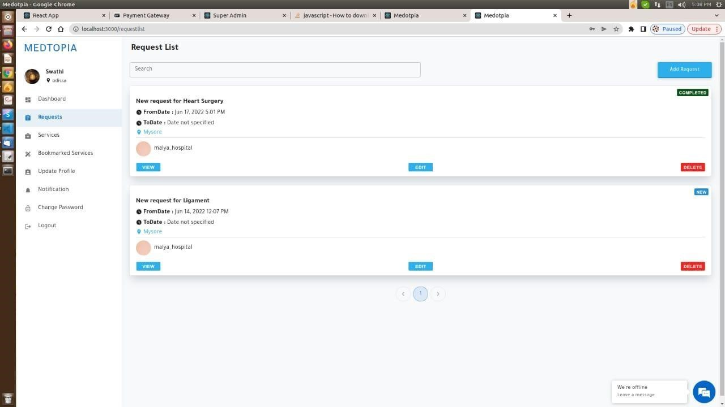

### Figure 6.2.g: User Request List Page

**h] User Profile Page:**

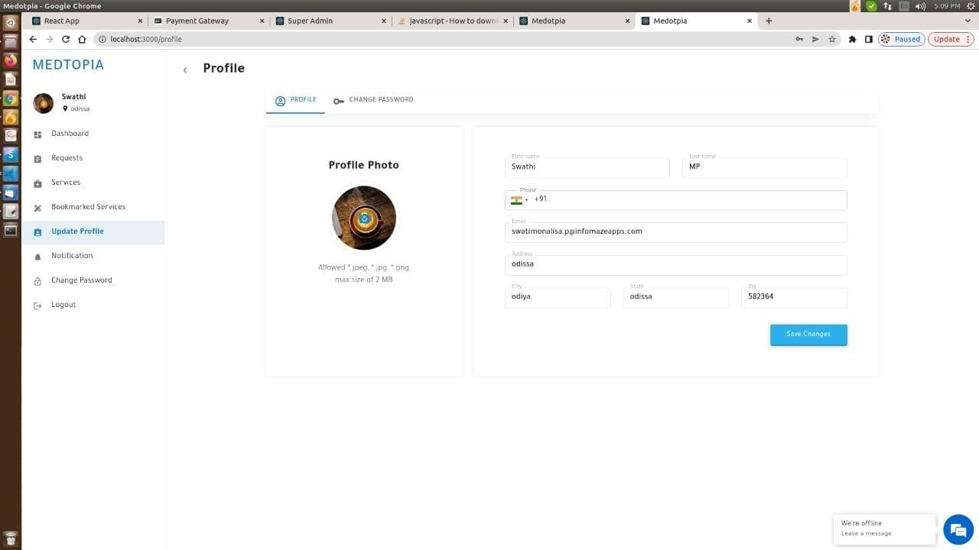

### Figure 6.2.g: User Profile Page

**B] Admin Page Details:**

**i) Admin Register Page**

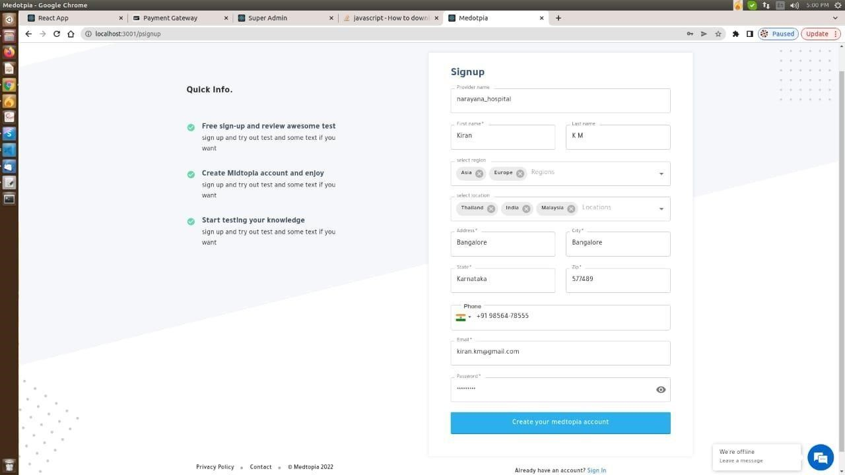

### Figure 6.2.B.i: - Admin Register Page

**ii) Admin Login Page:**



### Figure 6.2.B.ii: - Admin Login Page

**iii) Admin Dashboard Page:**

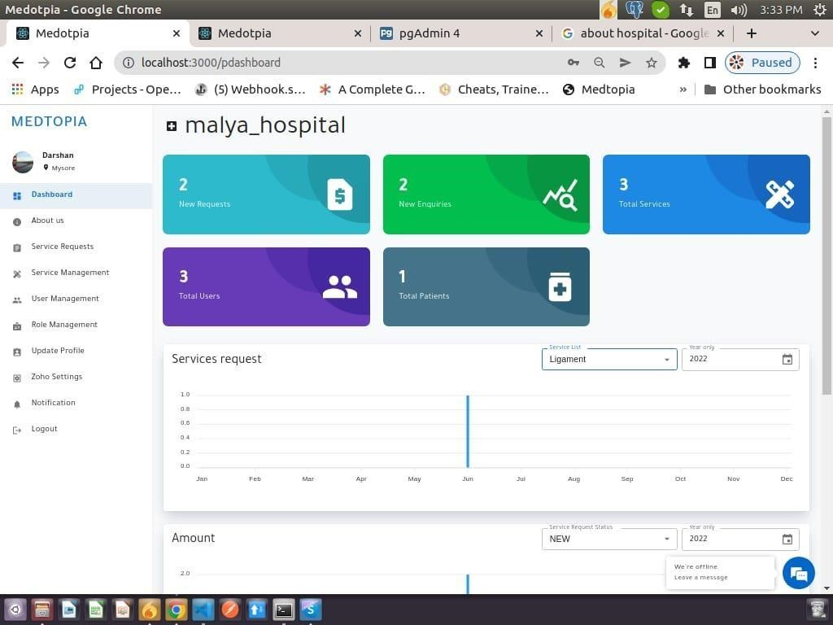

### Figure 6.2.B.iii: - Admin Dashboard Page

1. **Admin About Us Page:**

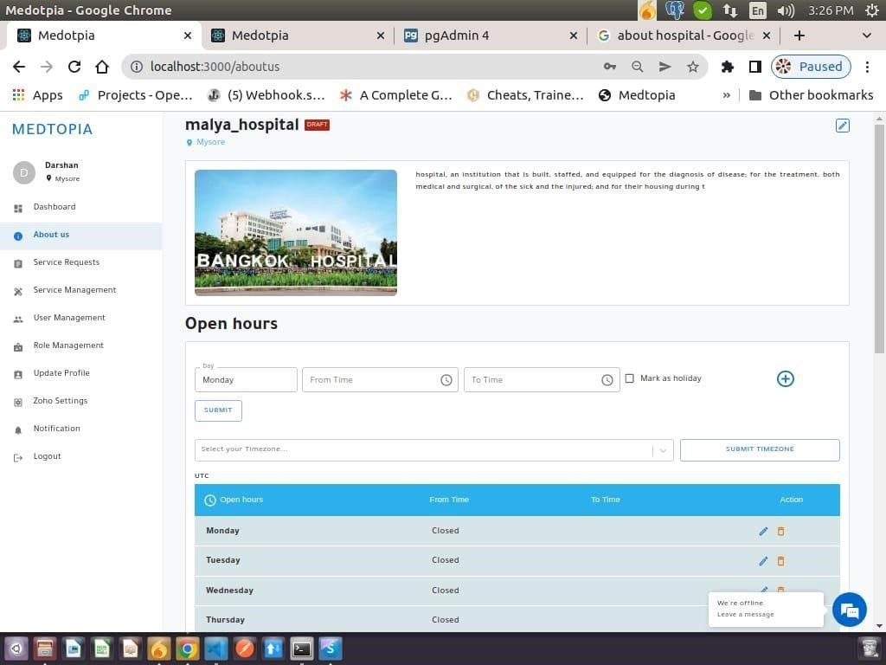

**Figure 6.2.B.iv: - Admin about Us Page**

1. **Admin Chat with User Page:**

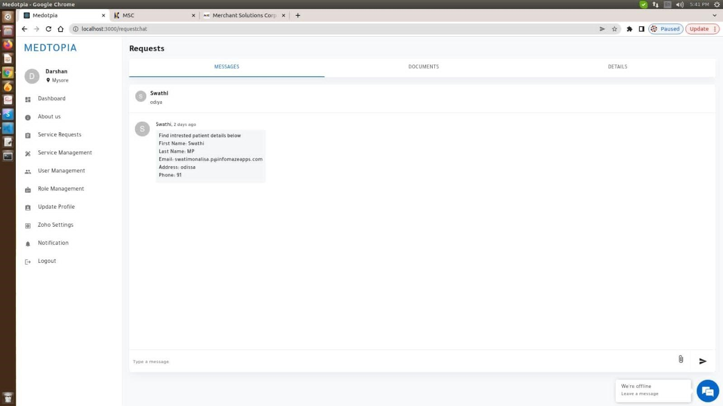

### Figure 6.2.B.v: - Admin Chat with User Page

**vi) User Management Screen of Admin Page:**

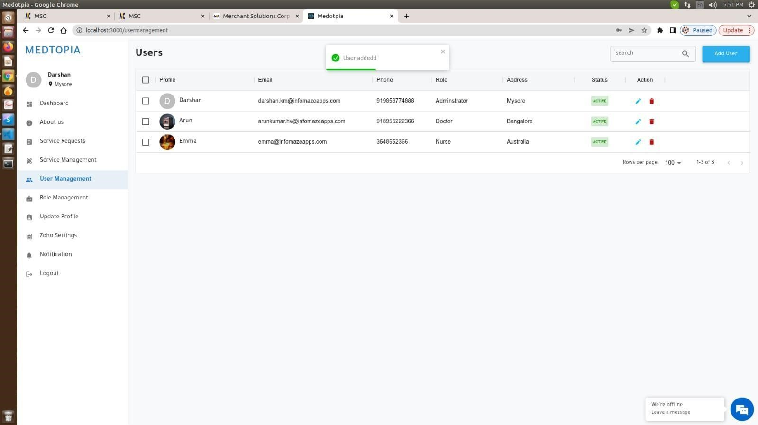

### Figure 6.2.B.vi: - User Management Screen of Admin Page

**vii) Service Management Screen of Admin Page:**

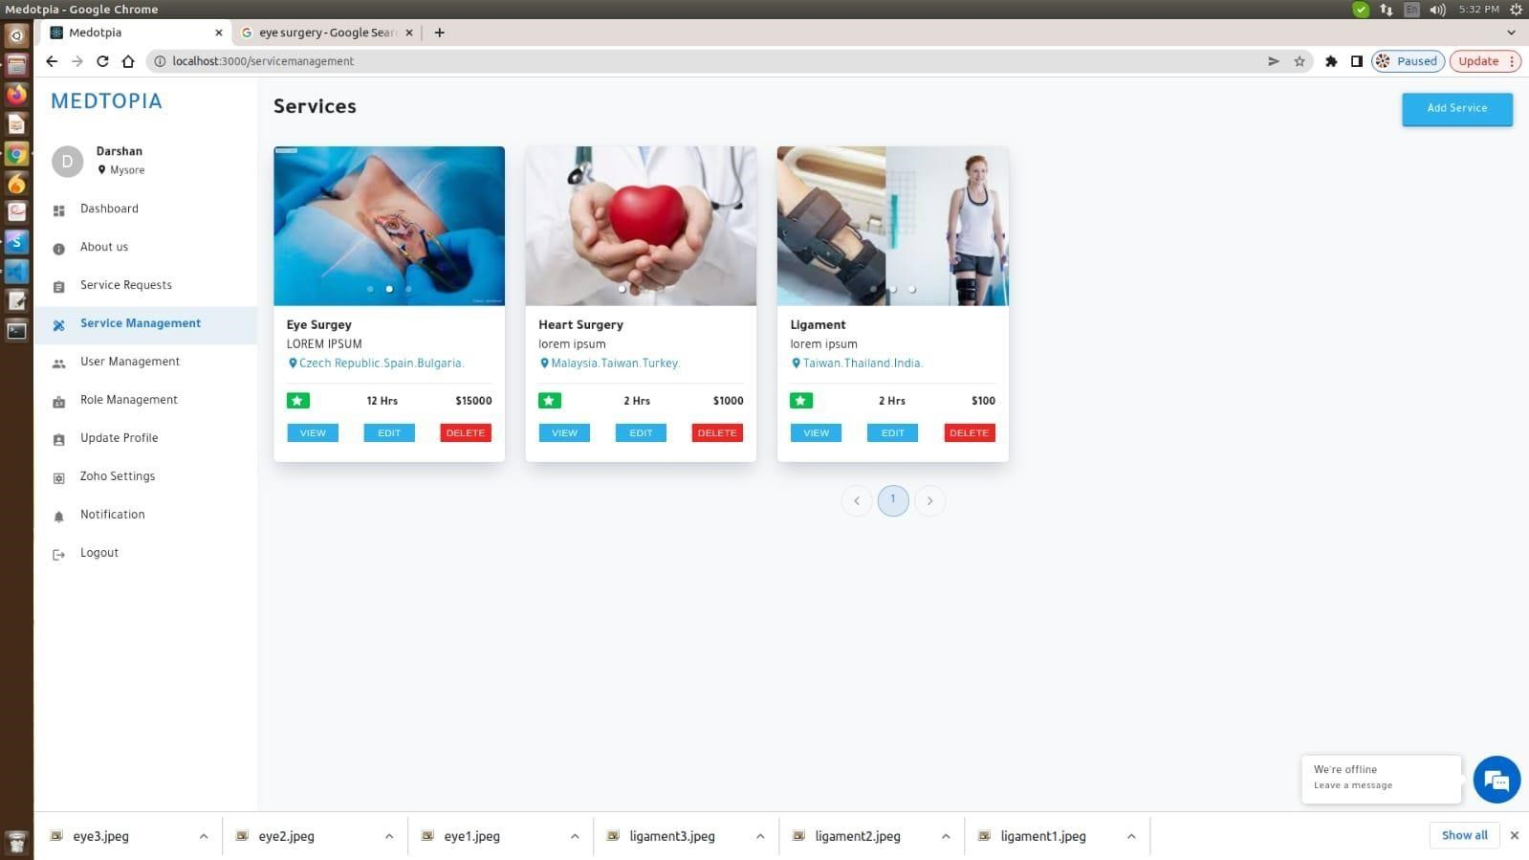

**Figure 6.2.B.vii: - Service Management Screen of Admin Page**

**viii) Admin Profile Page:**

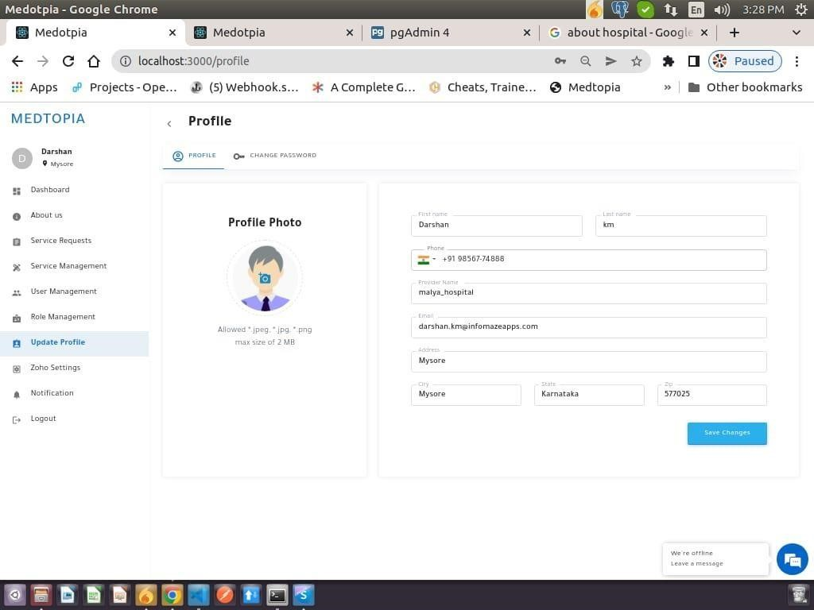

### Figure 6.2.B.viii: - Admin Profile Page

**INPUT AND OUTPUT DESIGN:**

**INPUT DESIGN**

These tools are important to bring information exchange into a suitable structure to manage it. This can be achieved by evaluating PCs to study information. From synthetic or printed data sets, or people can directly enter information into the frame. The communication plan focuses on controlling the required communication actions, checking for errors, avoiding delays, eliminating additional media, and maintaining basic communication. Information should provide security and convenience while maintaining protection. Consider the information design of accompanying elements:

* What information should be provided as information?
* How should the information be formatted or coded?
* Communicate and guide workers to provide information.
* Prepare information statements and methods of action to be taken when errors occur.

# Exercises

1. Information design is the approach from a customer-oriented article description to a PCbased platform.
2. It does this by making estimates easier to understand, so that the information part handles large amounts of information. The purpose of preliminary planning is to simplify the information part and avoid errors. All information control can be carried out. It also provides visitor registration points.
3. When entering information, check its legitimacy. Information can be entered through the screen. If necessary, a corresponding message will be sent so that the buyer is not busy with corn at this time. The goal of information configuration is to create an easy to-follow information format.

# Design service

High-quality service meets the requirements of end users and clearly represents data. Pass the refund to customers and other facilities. The performance plan defines how the data should be rooted to meet the needs and performance of the expression. It is the most meaningful and direct source of data for customers. Efficient and smart. Performance parameters affect the framework connection to support client dynamics.

1. PC performance planning should be coordinated and carefully reviewed; the correct performance needs to be constructed to ensure that each performance component is planned in a way that allows people to determine that the framework can use them effectively and appropriately. By the time the pc executes the course, the pc should have determined the specific achievements that should meet the conditions.
2. Select the data input method.
3. Create another file, report or configuration that contains the data provided by the framework.

The performance type of the data frame must meet at least one of the attached goals.

* + Transfer historical data, current state or forecast to

➢ Future.

* + Point out important events, opportunities, problems or condemnations.
  + Activation operation.
  + Confirmation of activity.

**CHAPTER – 7**

# SOFTWARE TESTING

**7.1 System Test**

The reason for testing is to find errors. Testing is an attempt to find all possible errors or defects in the work item. Provide a way to test the usefulness of segments, subcomponents, components, and another complete article. Carry out coding practices with plans to ensure that the software framework meets the needs of customers and will not fail under unacceptable conditions.

**7.2 Types of Tests**

## Unit testing

It involves designing experiments to prove works as expected and that the input produces significant results. All election offices and internal regulations must be approved. The application is made after the completion of the single property prior to joining. This is the main test, depends on your development information and is intrusive. Unit tests run critical segment level tests and test specific business interactions, applications, and framework layouts.

## Combination testing

The combination test is used to test the coordinated program segments to determine whether they are actually running as a single program. These tests are case-based, focusing more on the main results of the screen or panel. The mixed test shows that although each section runs independently, as has been effectively proved in the unit test, the combination of the various parts is correct and predictable. Identify problems caused by combining parts.

## 3. Useful test

Useful testing provides strong evidence that the functionality of the test is provided in accordance with business and professional requirements, structured documents, and customer guidelines.

Useful tests focus on relevant elements:

Key input: The identified category that needs to identify valid information.

Invalid entry: The allocated invalid information class should be discarded.

Skills: Recognized skills must be developed.

Performance: The recognized performance level in use will be defined. Structure/Program: A framework or interface strategy must be created.

Utility Test Prep and Association focuses on needs, key opportunities or unusual experiments. Similarly, accurately include various trade flows; information fields, predefined measurement values, and rolling periods should be considered when testing. Before the actual test is over, additional tests will be allocated and the validity of the current test will be determined.

## 4. Framework Test

Test framework ensures that the entire embedded programming framework meets the requirements.

## 5. White Box Testing

It is product analysts to understand the internal process, design and language of the product or their motivations. This is the reason. Used to test areas that cannot be detected grade.

## 6. Discovery Testing

It was found that the test tested the product without information about the interior, assembly, or language of the unit under test. As with most other types of testing, discovery testing should include an authoritative set of data sources (such as detailed reports) or prerequisites (such as specific or required documents). Opening can’t see.”

## 7. Unit Testing

Unit testing is usually performed as a function of the bundled code and the unit test cycle of the product life cycle, despite the coding and unit It’s not uncommon for tests to be performed as a separate step.

## 8. Test methodology and approach

Field tests for detailed preparation of physical and useful tests. All field passes should work properly.

* The page must be launched from a dedicated connection.
* Transition screen, Messages and responses should not be delayed.

Ensure that the partition configuration is correct.

* Copying of the partition is not allowed.
* All connections must direct the client to the correct side.

## 9. Incorporation Testing

The programming connection test is for at least two software Continuous testing of component consistency, these components are combined in one step, creating frustration through a desolate interface.

Test result: All the above experiments were successful. No stains.

# CHAPTER – 8

# CONCLUSION

* **Accessing Inaccessible:** In locations that were historically impoverished or unserved, Medtopia can give and enhance access to healthcare.

* **Improved quality of care:** Using interactive video and with key patient info available online, Medtopia enables conversation between the physician, the consultation physician, the patient, and the patient's family.

* **Reduced cost:** Travel expenses for patients seeking specialized treatment, travel expenses for medical professionals seeking ongoing education or advice, staff and value of the new associated with maintaining specialized care facilities in remote hospitals, and other expenses can all be avoided or reduced.

* **Reduced isolation:** For patient consultations and ongoing education, Medtopia offers a community and specialist contact.

# FUTURE ENHANCEMENTS

* The proposed system, called MEDTOPIA, can be improved by adding more services, such pharmacies.
* The central goals are to prioritize patient’s safety as well as to ensure that financial and operational sustainability of the sites they manage.

* Medtopia will become a Standard Service.

* Will Form Medical Services in Remote Locations to Connected Health.

* Remote Patient Care will be a Reality.

* Distance Education and Decision Support for Health Professionals.

## BIBLIOGRAPHY

* <https://www.medicaldepartures.com/>
* <https://softlinkinternational.com/telehealth-solution/>
* <https://www.practo.com/>